Ok to post to Webct for reference in MEEG 653 class - ECC

Making Skateboards

Liz Chalfant
September 29, 2004

Manufacturing Processes and Systems
MEEG 653
Self Selected Homework One

This is discussion on the manufacturing of skateboards. Extreme sports are a rapidly growing hobby. Skateboarding is considered the father or beginning of extreme sports. This is a design and manufacturing field that is expanding everyday. So learning a little about how skateboards are currently made today will help in the future technology of the industry.

A Little Background….
The earliest skateboards came out of Southern California in the 1930s. They were made from crates with wheels attached to the bottom. Later into the 1940s and early 1950s they were formed from planks of wood and scooter wheels. During the 1950s, surfing became a major fad sport. Skateboarding grew on the back of surfing. The new land sport was picked up by surfers who would “surf the sidewalks” when the waves were no good.
Manufacture of skateboards was not picked up until the late 1950s. The problem with the design before was that it was not very maneuverable. Production was picked up in the late 1950s with huge improvements to the trucks to fix this problem. The sport has since gone in and out of popularity with city bands on the sport and technology. Recently with all the hype that the sport has gotten from ESPN and MTV, the sport is making another comeback.

The Basics…
A skateboard is made of mainly three things; the deck, the trucks, and the wheels. This is shown in the picture below.

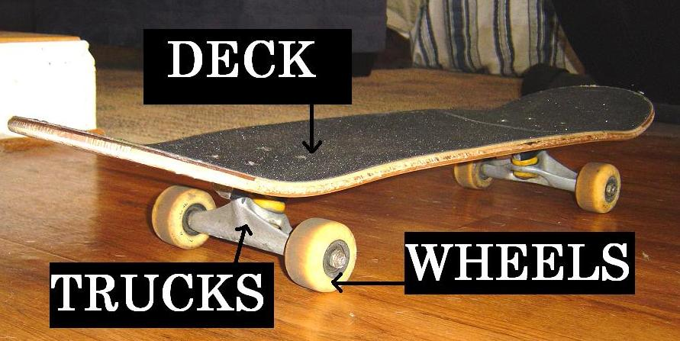
FIG 1

In addition to these three things, you have the grip for traction and the bearings. The grip is the black layer on the deck and the bearings are attached to the wheels that allow for low friction between the wheels and trucks.
Some skateboards come fully assembled, but most riders purchase all of these parts separately and assemble their own unique board.

The Deck…
The deck can be made of several different materials. Mostly the deck is made up of several different layers of wood and glue. Some decks also have several different layers of composites, fiberglass, aluminum, Plexiglas, foam, and nylon glued to the wood of made fully of it. You can see this in the following picture.
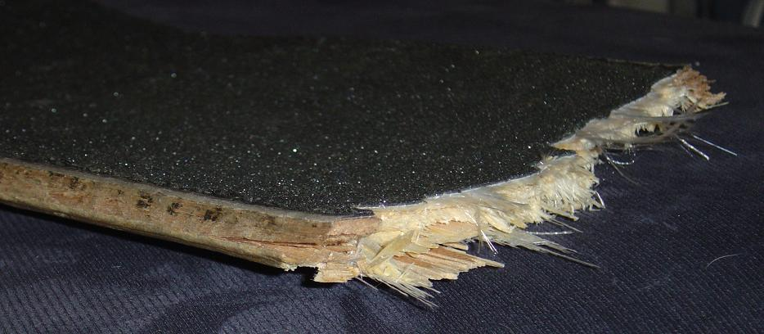
FIG 2

You can also see from FIG 1 that there is a large curvature to the deck. The curvatures allow the rider to handle the board in different ways and allow them to do a variety of tricks. The actual curves to the deck are unique to different companies depending on the type of ride they are trying to supply to the rider. The curvature is one of the main characteristics a buyer is looking for in a deck.
The other characteristic the customer is looking for in a deck is its strength. This comes into play in what the board is made of and how it is made. Many riders like to do tricks and grinds with there boards, so they don’t want them to break easily. This is why many companies use layers of other materials than wood to try to give it more strength.
The classic fully wood board is made in a few steps. First the wood undergoes treatment and is peeled into veneers. The veneers are then stored in a climate controlled area to avoid moisture build up which can cause warping in the wood and is not good for quality control. This wood is usually maple. The veneers are then manually put into a gluing machine where special water-based glue is coated all over them. The layers are then stacked on each other the way they will be found in the board. The stacks are then placed into a two-part mold inside a hydraulic press. The machine presses the molds together around the stacks to create the curvature and shape required. The stacks will stay in the press from a few minutes to a few hours depending on the quality of the board. The longer it stays in, the more time the glue has to set and create a better formation of the board. The next step is to cut the eight holes needed into the deck for the trucks. This is usually done manually with a drilling rig. Next, a worker takes a stack from the drill rig and, with the help of an already made template, cuts out each one of the boards from the stack with a band saw. Finally, the newly made deck is sanded, coated with a paint or sealant, decorated, and then shipped.
Usually in a wooden board there are several layers of the veneer. The grains of each veneer layer usually vary in different directions. It is important to note this because by varying the directions of the grains, you can control the strengths of the veneer in the directions you want to.

The Trucks…
Skateboard trucks are mostly made from aluminum, steel, brass, or some alloy. A close up of a truck reveals the following details.

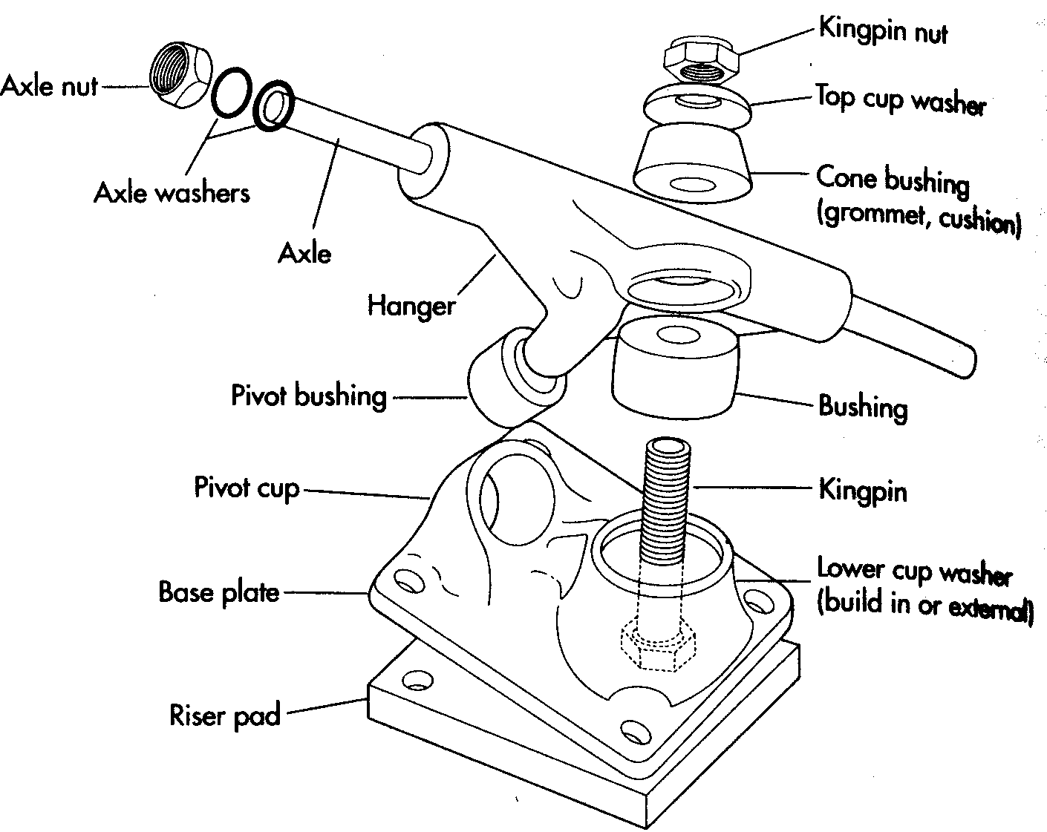
FIG 3

The washers, nuts, and bushings are usually bought from a specialized manufacturer when compiling the truck. The parts that are made by the truck manufacturer are the hanger, axle, pivot cup, kingpin, base plate, and riser pad.
The purpose of the truck is to give the rider better turning ability and board control. It is similar to the turning control of a car. A rider can control the direction of the board simply by leaning. As a rider leans to either side of the deck to turn that way, the truck allows to the wheels on the turning side to come closer together and actually angle the wheels to the desired direction. Without this, a rider would simply only be able to travel relatively straight.
The main process used to make the trucks is sand molding. First a replica of the truck is made from wood, plastic, or clay. This replica is then used to make a plate. A sand mixture is then secured around the plate to create the actual mold for the truck. In the case of an aluminum truck, aluminum ingots are heated to about 707°C until they are a liquid. The liquid is then poured into the sand mold and allowed to cool. Once cooled, the sand mold is broken up by hand and then the part is removed to be heat treated, grinded, polished, and drilled to its final finish. The last step is the manual process of putting all the bought and made parts together to be shipped.

The Wheels…
Skateboard wheels have to withstand constant friction and stress with the pavement while being ridden. Because of this, they are made of polyurethane. A close up picture of a skateboard wheel can be seen in the picture below.
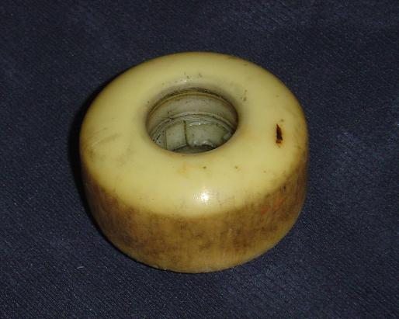
FIG 4

The wheel is really made from two processes. First the two polyurethane components of mixture are placed in a metering machine. Here they are mixed and melted to a liquid. High quality wheels are mixed together at higher temperatures versus a lower grade wheel that could have mixed together at room temperature. The liquid is then poured into an aluminum mold and allowed to cool until solid. They are then removed from the molds and allowed to cure. The second process is to then take the wheels and place them on a lathe. The wheel slug, sidewalls and tread is then manually cut out with the lathe.

The Assembly…
Once the pieces are all made, they are ready to be put together. First the grip tape is manually places on the deck, making sure that it is fully stuck to the deck and that there are no air holes. Then the grip tape is trimmed and the truck holes are punched out. Once the deck is together, the two trucks can be attached to the deck. The bearings are then manually pushed into place in the wheel and then bolted to the axle of the trucks.
This process is all done manually. It is now ready to ride.

A Little Economics…
In 1997 there were 8.2 million skateboarders. A moderately aggressive skateboarder will go through an average of three boards each year. An average deck will cost 70$, an average set of wheels will cost you $40, and an average set of trucks will also cost you $40. So an average board will run a customer $150. This is over 1.23 billion dollars in revenue a year industry! However the costs to make the boards are not cheap. A press can cost a company $50,000, a nice band saw can cost $5,000, a lathe can cost $10,000, and a sand casting process can cost over $100,000. In addition to these costs the companies still have to pay for the raw materials and overhead costs. As you can see, a single company will have to sell many components in order to keep the costs of them down so that riders can buy the parts. There are a lot of manual processes in the entire manufacture. Future improvements in automation may help this industry reduce the costs of production which may increase the popularity of the sport.

Relevance…
The major significance of this topic for a beginning engineer is that it shows the extensive amount of steps that a simple thing like a skateboard has to undergo to be manufactured. It not only shows them that there are a lot of steps involved in the manufacture of it but that there is a wide variety of manufacturing processes used. The entire process incorporates presses and band saws to sand casting and lathe cutting. In addition, a beginning engineer should also recognize the large amount of manual labor needed to run this process. Improvements can be made in the automation of the manufacturing to try to increase production with the increase demand.
The major significance of this topic to a mature engineer would be the quality of the materials and methods used in the current manufacturing process to create better products. The methods for making skateboards have not changed much since they started to be manufactured in the 1950s.

Learning…
I believed that the manufacturing processes of making a skateboard were few and simple, then I learned that there are about 12 different major steps to making the three major parts of a skateboard through a variety of techniques, so I realized that each step is costly and then learned that there is more engineering involved in the making and manufacture of a skateboard to increase quality and ease of manufacture then it seems.

Bibliography…

- Sun Lim, Kyung, How Products Are Made; an Illustrated Guide to Product Manufacturing Vol. 6. Gale Research, 1996.
- http://www.evileds.com/links/history_of_skateboarding.htm, September 24, 2004.
- http://www.skateboarddirectory.com, September 24, 2004.

